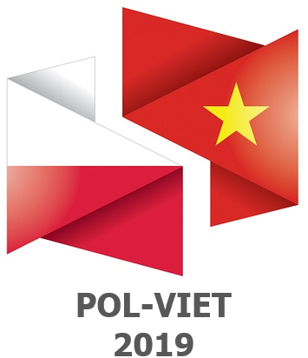

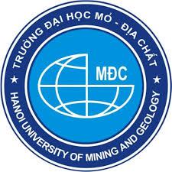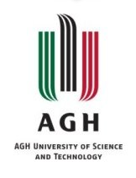

**5th International Conference POL-VIET 2019**

**1st Call for papers**

**The 5th International Conference „Scientific-Research Cooperation between Vietnam and Poland” (POL-VIET) 8 – 10 July 2019**

It is a pleasure to invite you to 5th International Conference “Scientific-Research Cooperation between Vietnam and Poland”. The conference will take place in Krakow on 8-10 July 2019. The conference will take place during the celebration of the 100th anniversary of the AGH University of Science and Technology foundation.

**Conference Venue:**  
AGH University of Science and Technology,   
A. Mickiewicza Av. 30, 30-059 Krakow, Poland

**Topics of interest:**

* Applied Physics
* Drilling
* Geodesy and Mining surveying
* Geology and Geoturism
* Geophysics
* Humanities
* Materials Engineering
* Mining

**Important dates:**

Conference registration deadline: 30 May 2019

Abstract submission deadline: 30 January 2019

Notification of acceptance: 28 February 2019

Final full paper submission deadline: 30 March 2019

**Guide for authors:**  
Maximum one standard page, 1800 characters with spaces in English.

**Conference fee:**

* Vietnamese participants: 50 Euro
* Other participants: 150 Euro

**Organising institutions:**

AGH University of Science and Technology, Hanoi University of Mining and Geology

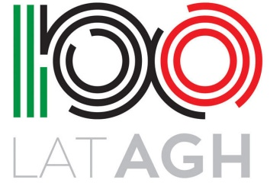**For all enquiries, please contact:** polviet@agh.edu.pl